HR 2 BREAKDOWN

TEAM: [State Team number and Name here]

Due Date:
Friday, March 6, 2020 at 11:59pm

Provide several pics of the current state of your completed system thus far here:

The team is working on a project which is to make a balancing robot and it can travel on any sort of terrain without losing the balancing and can travel for long time. For this purpose, the team has proposed a design of two wheeler robot with the balancing capacity using the gyroscope. Now the team is in a process of manufacturing the product. In the previous hardware review, the purchased components have described and in this hardware review, team will present the updated model of robot and will provide the details about each component with its working, using in the robot. First of all, a prototype has developed in the previous semester and the design was supposed to follow that prototype but the physical shape of robot has little changed in actual product. The team has currently developed the following product
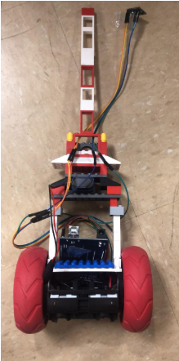
Figure 1: Final Product

As it can be seen in the figure 1 that a two wheeler robot is present with a vertical shaped body. The body structure of robot has developed using the plastic. And the closer look is showing below in which
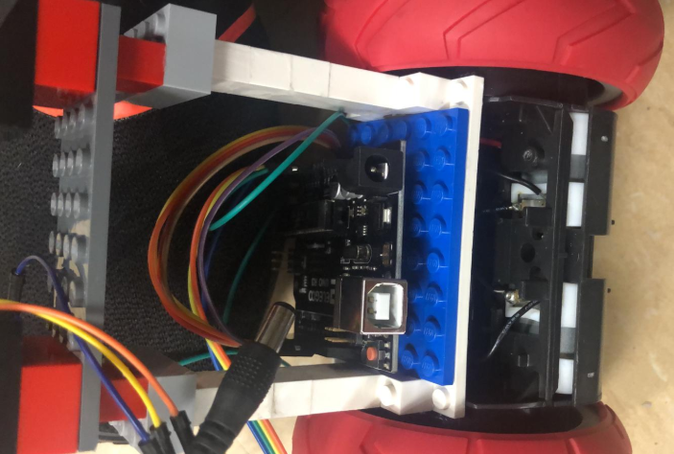
Figure 2: Central body of robot in close up

The robot has two platform panels in the structure and both of them have developed with the dotted ground one is showing in blue color and second is showing in gray color. In the first floor, Arduino has placed and all the connections have made from there. In the upper floor, sensors have placed to tackle the robot stability and keep it balancing, while the motor controllers are present in the base which are connecting with the Arduino and then connecting with the motors. The wheels have connected with the four motors, two motors on each side and two motors on side are connecting with the wheel through the circular shaft, and the motors have connected in line through the base chassis. The sides of the robot have developed with the single strand pillar on both sides, and it connected with the base where the wheels are connecting through the shaft.

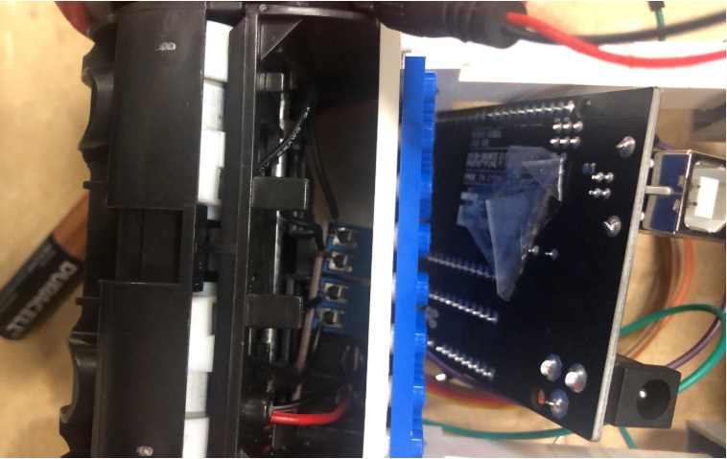
Figure 3: Base Chassis
And the radius of wheels is large to provide the stability to the robot. The whole robot is connecting with the main controller that is Arduino and the connection of Arduino has shown below

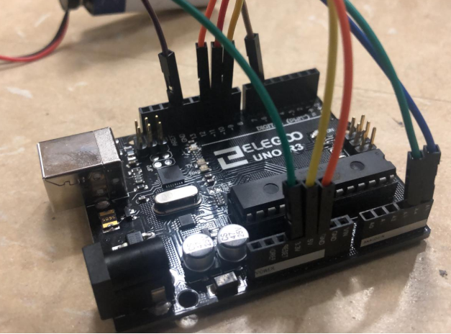
Figure 4: Arduino controller connections

The Arduino is connecting with the gyroscopes to stabilize the robot, and also connecting with the motors through the controller to control the motors, there is a pin to provide the battery power. Accelerometer and the connection with the batteries and wheels are showing in the following figure.

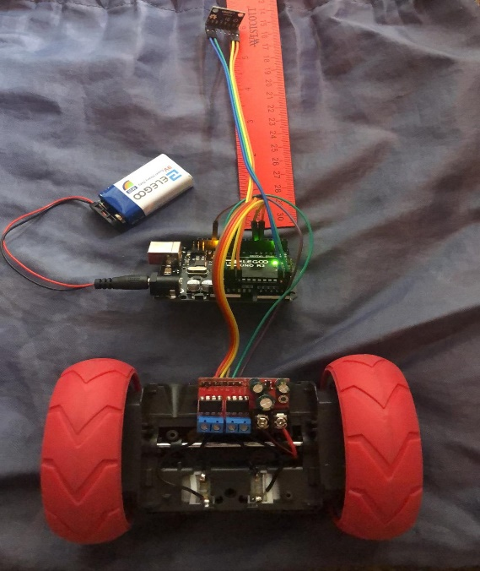
Figure 5: Accelerometer and connection with wheel

The following are the Action Items each person completed between Hardware Review 1 and Hardware Review 2:

Team Member: Fahad Alostath
Action Item | Date Completed | Result/Proof of Completion
Connected Arduino | 02-22-2020
Connected the wheels | 02-24-2020 | 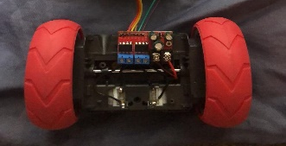
Connected The batteries | 02-25-2020 | 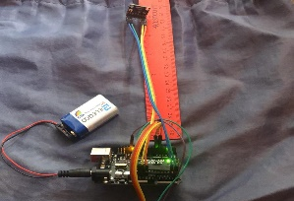
Developed the Structure | 02-29-2020

Team Member: Naif Alfihan
Action Item | Date Completed | Result/Proof of Completion
Connected the Accelerometer | 02-23-2020 | 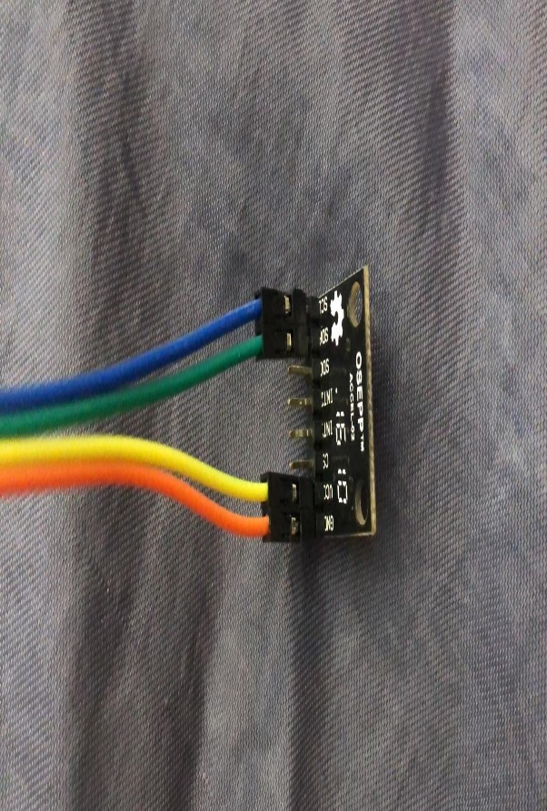
Connected the Gyroscopes | 02-25-2020
Developed the Body Structure | 02-29-2020

The following are the Action Items for each team member between HR 2 and the Final Product presentation:

Team Member | Action Items | Date Due
Fahad Alostath | - Connected the Arduino  - Connected the wheels  - Connected the Batteries  - Developed the structure | - 02-22-2020  - 02-24-2020  - 02-25-2020  - 02-29-2020
Naif Alfihan | - Connected the Accelerometer  - Connected the Gyroscopes  - Developed the Body Structures | - 02-23-2020  - 02-25-2020  - 02-29-2020

